**Period-over-period growth**

Period-over-period growth automatically selects one of the measures previously described in this section based on the current selection of the visualization.

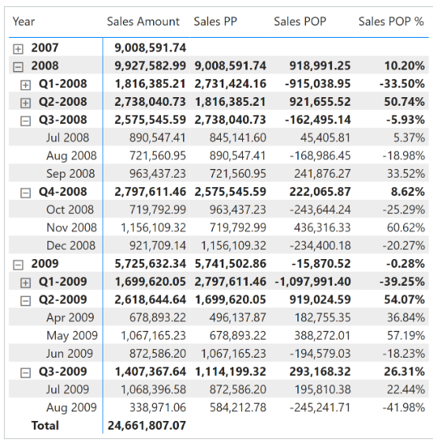 The three measures Sales PP, Sales POP, and Sales POP % redirect the evaluation to the corresponding year, quarter, and month measures depending on the level selected in the report. The [**ISINSCOPE**](https://dax.guide/isinscope/?aff=dax-patterns) function detects the level used in the report. The arguments passed to [**ISINSCOPE**](https://dax.guide/isinscope/?aff=dax-patterns) are the attributes used in the rows of the Matrix visual in Figure 8. The measures are defined as follows:

Sales POP % :=

SWITCH (

    TRUE,

    ISINSCOPE ( 'Date'[Year Month] ), [Sales MOM %],

    ISINSCOPE ( 'Date'[Year Quarter] ), [Sales QOQ %],

    ISINSCOPE ( 'Date'[Year] ), [Sales YOY %]

)

Sales POP :=

SWITCH (

    TRUE,

    ISINSCOPE ( 'Date'[Year Month] ), [Sales MOM],

    ISINSCOPE ( 'Date'[Year Quarter] ), [Sales QOQ],

    ISINSCOPE ( 'Date'[Year] ), [Sales YOY]

)

Sales PP :=

SWITCH (

    TRUE,

    ISINSCOPE ( 'Date'[Year Month] ), [Sales PM],

    ISINSCOPE ( 'Date'[Year Quarter] ), [Sales PQ],

    ISINSCOPE ( 'Date'[Year] ), [Sales PY]

)